**Abdul-THU-5P 4 Assignment 3**

Tutor - Abdul Obeid

**Jackson Hall – N10504915**

**Justin Hughes – N10206191**

**Trần Vũ Nhất Nam – N10306234**

Website

# Website Access

**Link -** [**https://virtuosity.herokuapp.com/**](https://virtuosity.herokuapp.com/)

# Demonstration

## Landing page (#1)

  
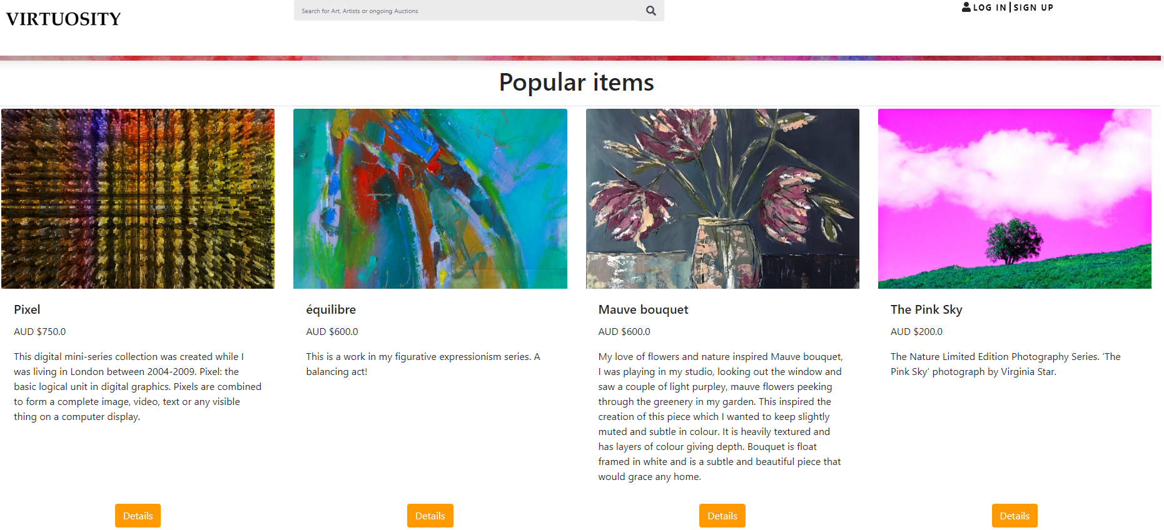  
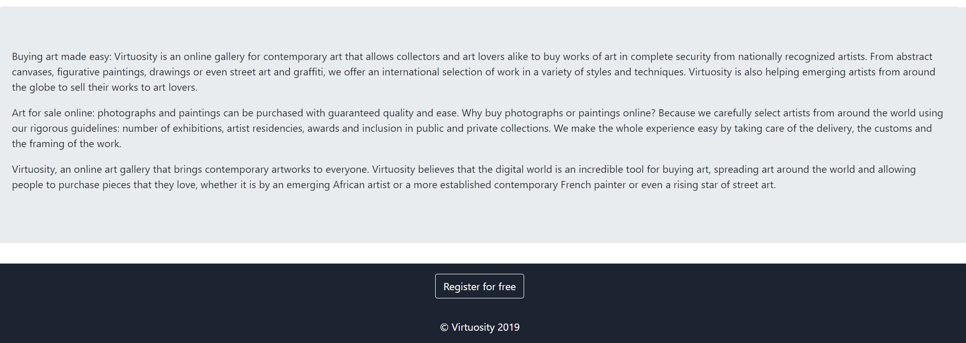

### Landing Page Description

This is the initial page that the user first encounters, the layout did change from the conceptual HTML in Assignment 2 to now as we incorporate elements required by the specification. This page incorporates

## Search results page (#2)

Images

### Search results description

describe

## Item details page (#3)

## Seller Manage Item page (#4)

## Updating Sale Information (#5)

## Item creation form (#6)

## User registration page (#7)

## User login page (#8)

## Seller past sales page (#9)

## Error handling (#10)